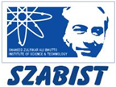 **Introduction to DevOps**

**BCS/BS 6A**

Lab: 06

# GROUP MEMBERS:

MUHAMMAD SHAYAN SHAHID (2212325)

MUHAMMAD ASHAD BAIG (2212115)

Task 1: Create a virtual machine

In this task, we will create a Windows Server 2019 Datacenter virtual machine.

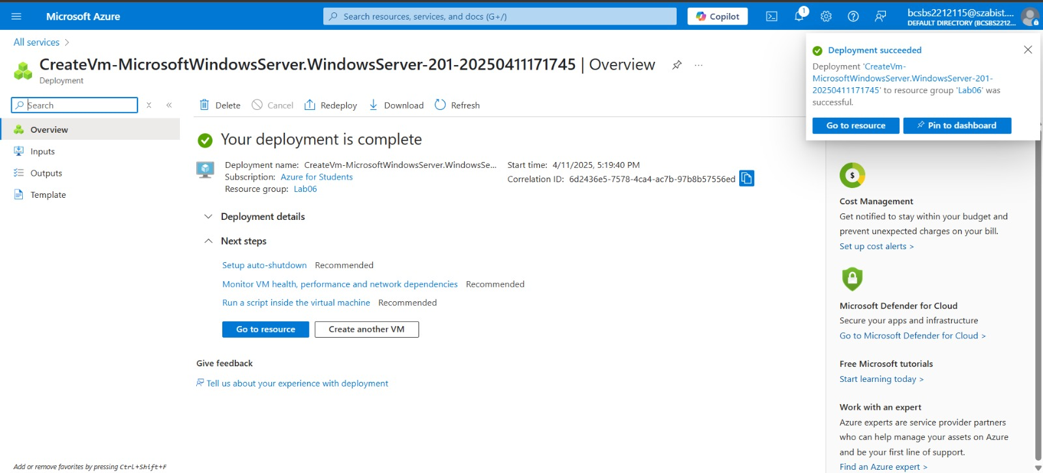

Task 2: Create a network security group

In this task, we will create a network security group and associate it with the network interface.

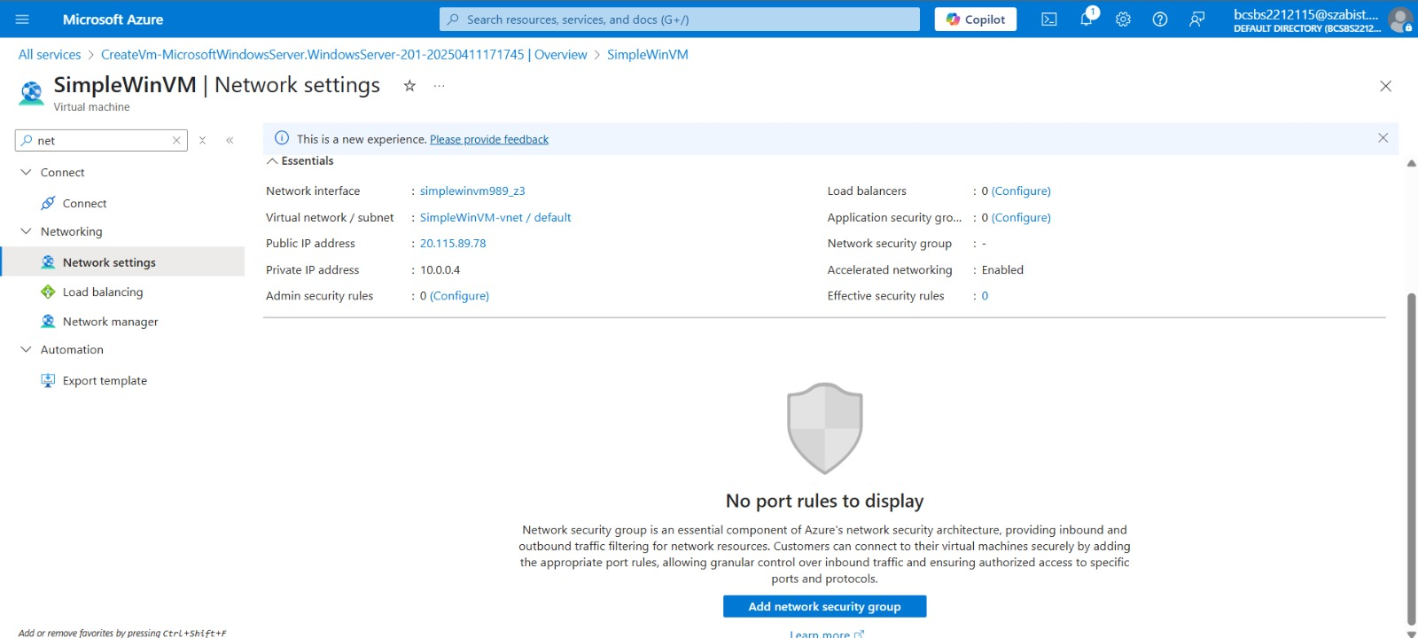  
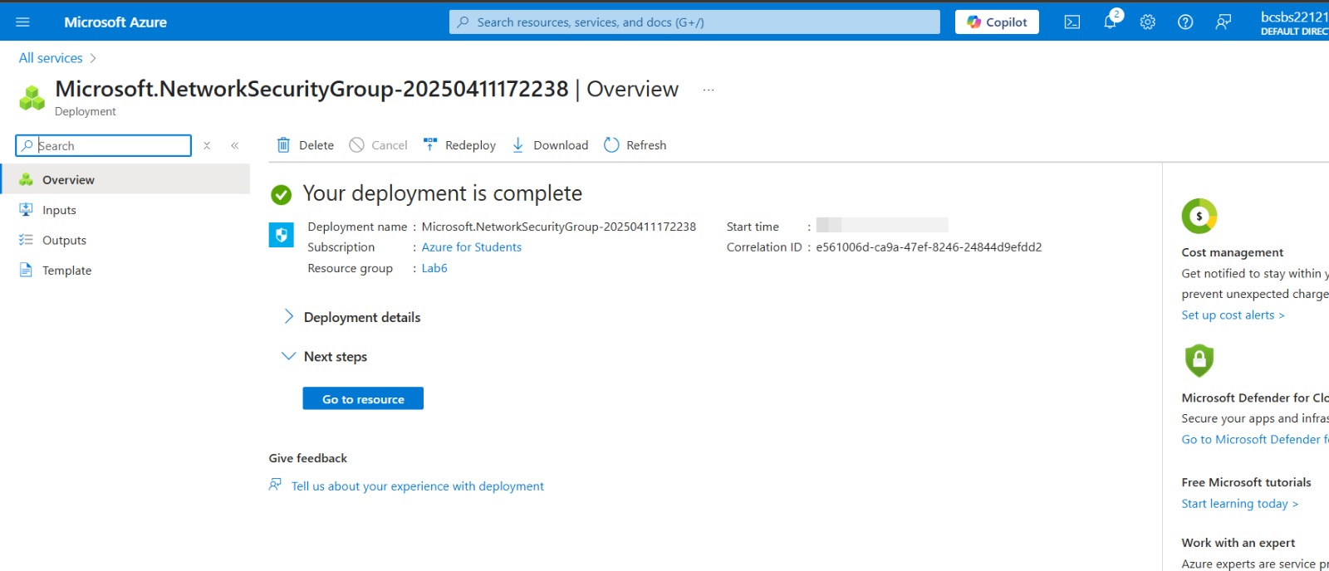

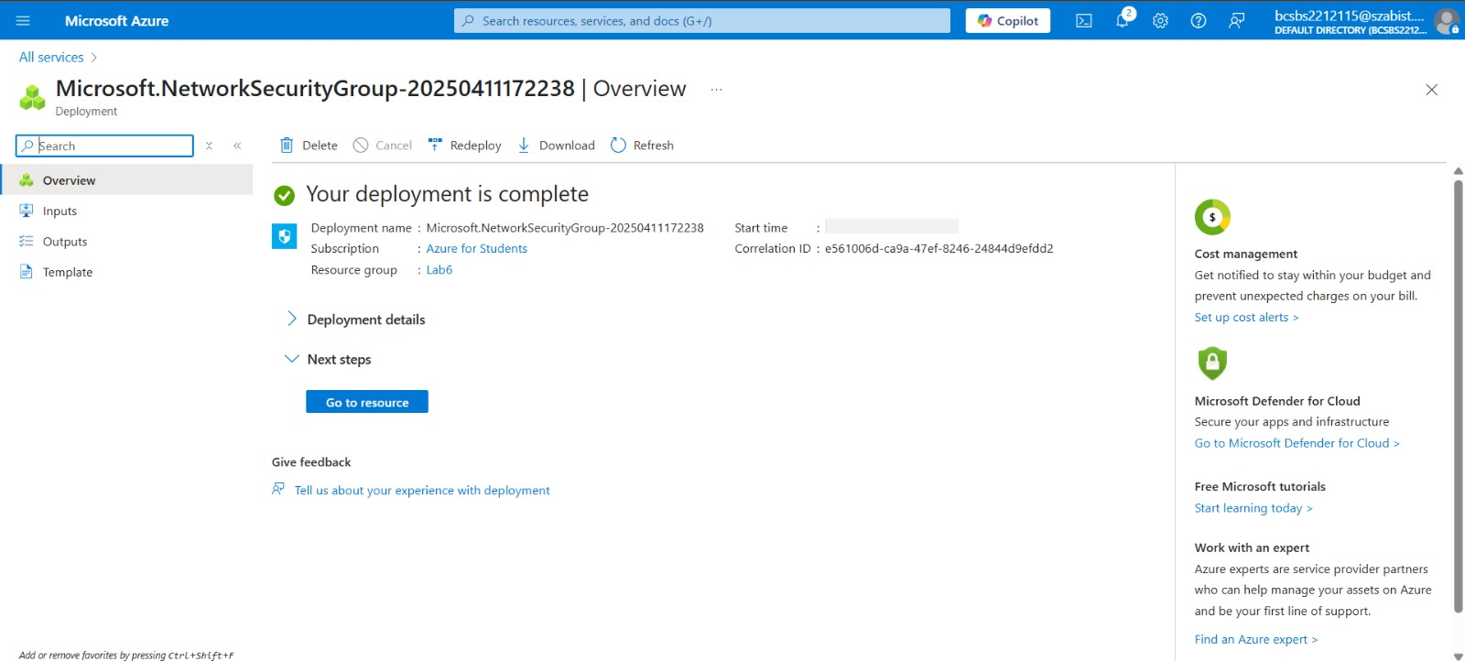

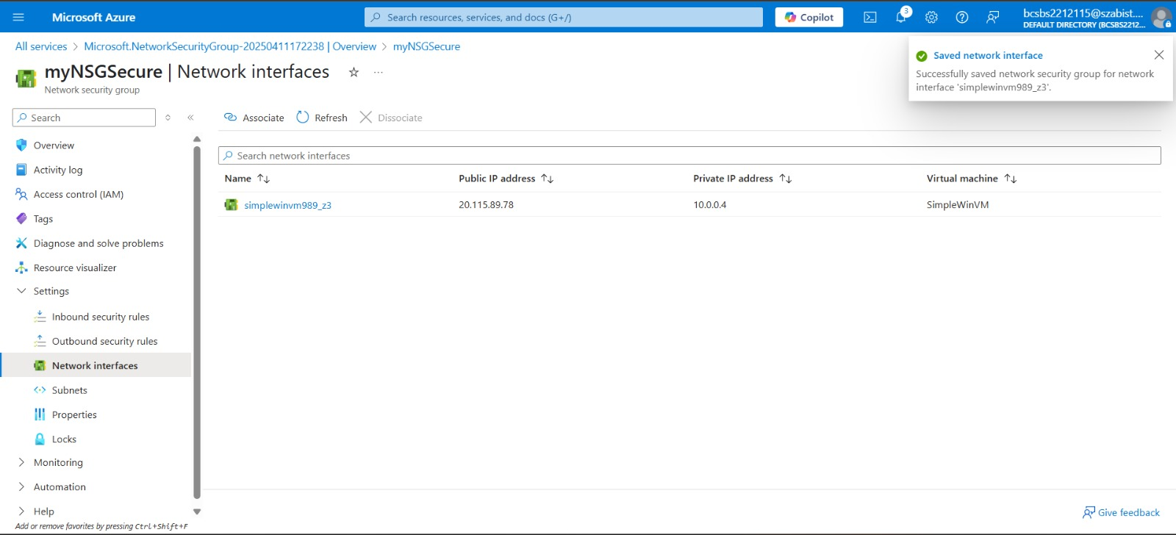

Task 3: Configure an inbound security port rule to allow RDP

In this task, we will allow RDP traffic to the virtual machine by configuring an inbound security port rule.

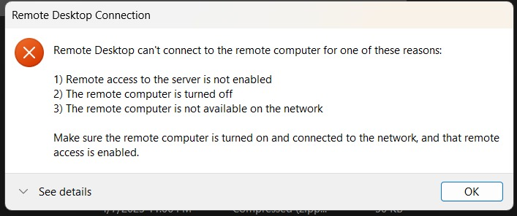

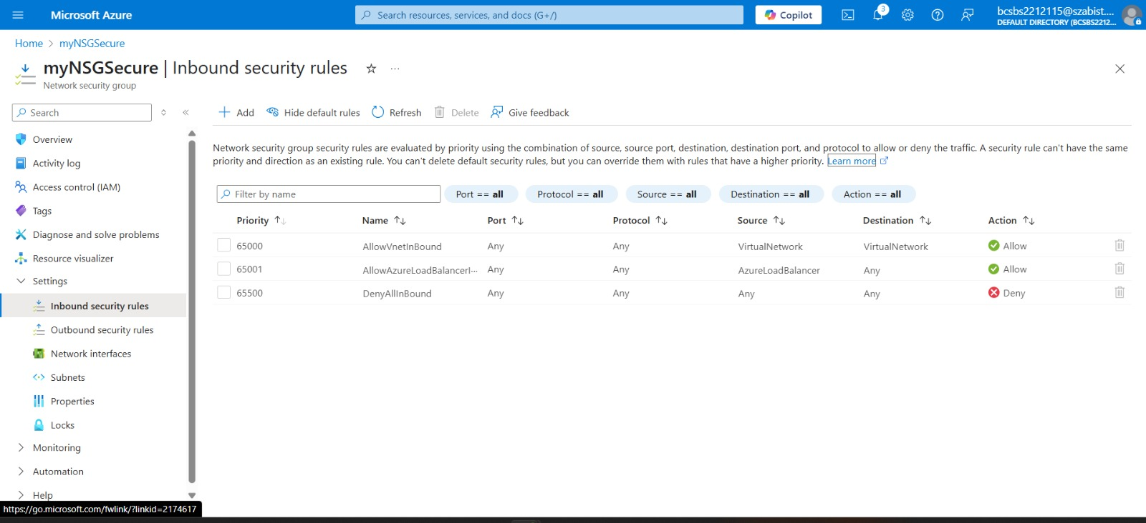

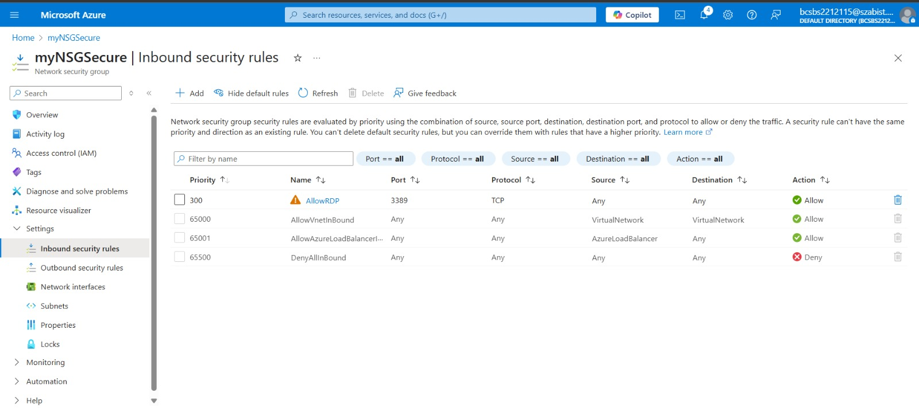

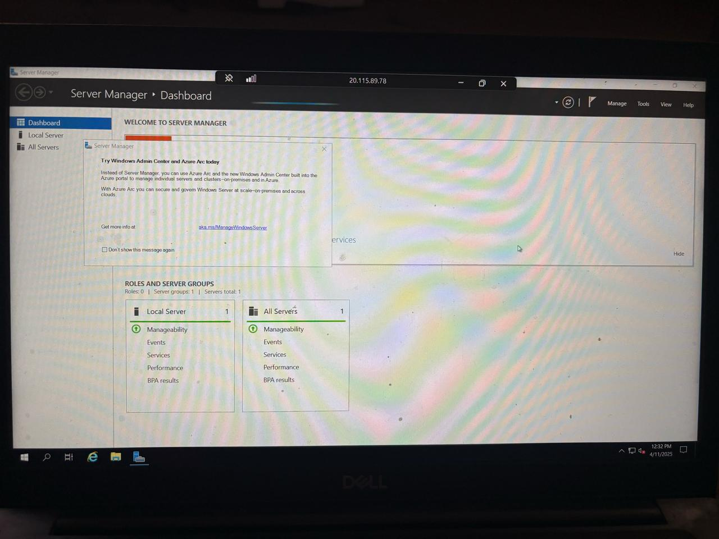

Task 4: Configure an outbound security port rule to deny Internet access

In this task, we will create a NSG outbound port rule that will deny Internet access and then test to ensure the rule is

working.

